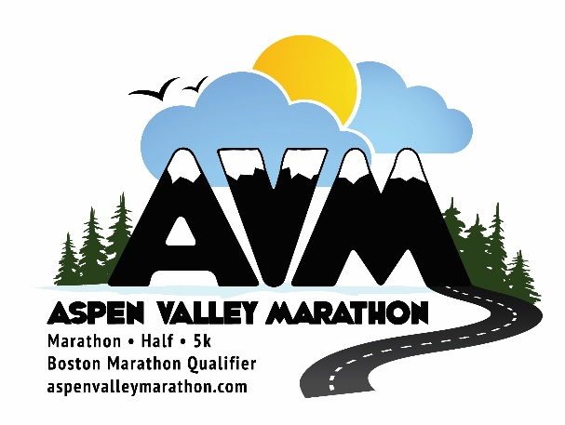

Aspen valley marathon July 11, 2020

COVID-19 RACE UPDATES
Aspen, May 17: After carefully considering the options for our 2020 races, we have decided to share the sad news that there will not be an Aspen Valley Marathon, Half Marathon, or 5k this year.
We have been hosting our marathon since 2010 through sun, rain and even with the embers of the huge Lake Christine fire still burning as the race passed in 2018. It is heart-breaking to not be able to host you in Aspen this year, but the health and safety of our runners, our volunteers and our entire community must be our absolute top priority.

At the date of writing the Pitkin County Health Order prohibits events or gatherings of more than 10 persons and requires people to maintain social distancing of 6 feet. We hope that this will be further relaxed as the pandemic is contained and normal life can resume for all of us, but it is unclear when this will happen. Many of the big city marathons have already been postponed and some scheduled for fall 2020 such as Berlin have already been cancelled. With so many uncertainties, we also need to give our loyal participants time to make new plans, cancel flights and get hotel stays refunded. We will do our part by providing an automatic deferral of your entry to the 2021 race which will be our 12th Anniversary Race scheduled to take place on Saturday July 17, 2021. So you do not need to do anything, you will be automatically entered into the 2021 race and we will be happy to change you from Marathon to Half or vice versa if you let us know by email in early 2021. We are committed to making our next race the best one yet.
Please know that the many hours and miles you put into training for the 2020 race did not go to waste. Now is the time to focus on what we can control and the many things that bring us happiness. For many of our loyal participants, running is one of those things and we feel privileged here in the United States to still be able to go for a run during these difficult times.
Thank you for your continued support throughout this difficult decision. We will continue to communicate additional updates to you and look forward to seeing you on July 17, 2021.

Thank you and best regards,

Kat Adams, Kylee van Horn & Sean Solon
The AVM Team 2020

